Specification Grid-2081

Class:-1

Sub:- Science

1st Term Total Working Days:- 57

Science - 1, 2, 3, 4, 5

Health - 20, 21

Physical Education - 26, 27

Lesson should be finished for first term exam.

2nd Term Total Working Days:- 44

Science - 6, 7, 8, 9, 10

Health - 22, 23

Physical Education - 28, 29, 30

Lesson should be finished for second term exam.

3rd Term Total Working Days:- 55

Science - 11, 12, 13, 14, 15

Health - 24, 25

Physical Education - 31, 32, 33

Lesson should be finished for third term exam.

FinalTerm Total Working Days:- 42

Science - 16, 17, 18, 19

Physical Education - 34, 35

Lesson should be finished for final term exam.

First Terminal Examination Grid :-2081

Class:-1 F.M=50

Sub:- Science P.M= 20

|  |  |  |  |  |  |  |
| --- | --- | --- | --- | --- | --- | --- |
| S.N. | Types of questions | No of Q.N | Opt | Q.N to be done | Weight | Total |
| 1. | Fill in the blanks. | 4 |  | 4 | 1 | 4 |
| 2. | True or False. | 4 |  | 4 | 1 | 4 |
| 3. | Match the following. | 4 |  | 4 | 1 | 4 |
| 4. | Choose the correct answer. | 4 |  | 4 | 1 | 4 |
| 5. | Circle the odd one. | 4 |  | 4 | 1 | 4 |
| 6. | Fill in the missing letters. | 4 |  | 4 | 1 | 4 |
| 7. | Re-arrange the letter. | 4 |  | 4 | 1 | 4 |
| 8. | Write the name of the following. | 4 |  | 4 | 1 | 4 |
| 9 | Answer the following question. | 7 | 1 | 4 | 1 | 12 |
| 10 | Give the definition. | 2 |  | 2 | 1.5 | 3 |
| 11 | Draw the picture. | 1 |  | 1 | 3 | 3 |

2nd , 3rd , 4th Terminal Examination Grid :-2081

Class:-1 F.M=50

Sub:- Science P.M= 20

|  |  |  |  |  |  |  |
| --- | --- | --- | --- | --- | --- | --- |
| S.N. | Types of questions | No of Q.N | Opt | Q.N to be done | Weight | Total |
| 1. | Fill in the blanks. | 4 |  | 4 | 1 | 4 |
| 2. | True or False. | 4 |  | 4 | 1 | 4 |
| 3. | Match the following. | 4 |  | 4 | 1 | 4 |
| 4. | Choose the correct answer. | 4 |  | 4 | 1 | 4 |
| 5. | Circle the odd one. | 4 |  | 4 | 1 | 4 |
| 6. | Fill in the missing letters. | 4 |  | 4 | 1 | 4 |
| 7. | Identify the following. | 4 |  | 4 | 1 | 4 |
| 8. | Write the name of the following. | 4 |  | 4 | 1 | 4 |
| 9 | Answer the following question. | 7 | 1 | 4 | 1 | 12 |
| 10 | Give the definition. | 2 |  | 2 | 1.5 | 3 |
| 11 | Draw the picture. | 1 |  | 1 | 3 | 3 |

**First Terminal Examination**

Model Questions - 2081

Class:-1 Time:- 2:00 Hrs F.M=50

Sub:- Science P.M= 20

**Q.1) Fill in the blanks. 4x1=4**

( living things, towel, two, grow)

1. Cow is a ..................
2. We should wipe our face with a clean ...............
3. I have a ................ eyes.
4. Non- living do not ...............

**Q.2) True or False. 4x1=4**

1. Living things do not move.
2. Tiger and cat do not eat food.
3. Non-living grow.
4. Tiger and lion are herbivores animals.

**Q.3) Match the following. 4x1=4**

1. Walking Non-Living things
2. Book Legs
3. Herbs Flower
4. Rose Very small plant

**Q.4) Choose the best answer. 4x1=4**

1. Tiger is a ..................... animals. (Omnivores/Carnivores)
2. Apple is a ...................... plant. (Small/Big)
3. Tree are ........................ things (living/Non-living)
4. Most plants are ..................... in color. (green, red)

**Q.5) Circle the odd one. 4x1=4**

1. Cow Goat Hen
2. Sheep Bear Fox
3. Rose Lily School
4. Stone House Tree

**Q.6) Fill in the blanks. 4x1=4**

**a) S c _ o _ l b) T _ e e c) E _ r d) P_ n**

**Q.7) Re-arrange the letter to make word. 4x1=4**

1. Monkey ________________________
2. Birds_____________________________
3. Apple____________________________
4. Net______________________________

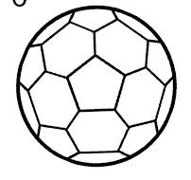**Q.8) Write the name of the followings.**  **4x1=4**

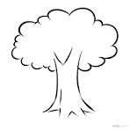 a) b)

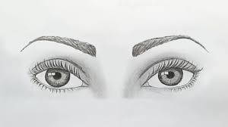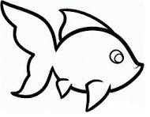 c) d)

Q.9) Answer the following Questions. 6x2=12

1. Write any four living things.

Ans:-__________________________________________________________.

1. Name any two body parts.

Ans:-__________________________________________________________.

1. How many times do you brush your teeth in a day?

Ans:-__________________________________________________________.

1. What is herbivores animals?

Ans:-__________________________________________________________.

1. Write any four fruits name?

Ans:-__________________________________________________________.

1. What are running?

Ans:-__________________________________________________________.

1. How many ears do you have ?

Ans:-__________________________________________________________.

**Q.10) Give the definitions of. 2x1.5=3**

a) Cow

_________________________________________________________

__________________________________________________________

__________________________________________________________.

b) Flower

__________________________________________________________

__________________________________________________________

__________________________________________________________.

**Q.11) Draw the pictures of 3x1=3**

**Bird Flower Umbrella**

**Second Terminal Examination**

Model Questions - 2081

Class:-1 Time:- 2:00 Hrs F.M=50

Sub:- Science P.M= 20

**Q.1) Fill in the blanks. 4x1=4**

( Life, Move, two, piglet)

1. Plants and animal have........................
2. Animals ................... from one place to another.
3. I have .......................... eyes.
4. The baby of pig is called................................

**Q.2) True or False. 4x1=4**

1. Cow and buffalo eat only plants.
2. Man and Bear are omnivores.
3. Dog eat both plants and flesh.
4. Food gives us energy to do work.

**Q.3) Match the following. 4x1=4**

1. Dog Vegetables
2. Apple Puppy
3. Cabbage Fruit
4. Tree Living Things

**Q.4) Choose the best answer. 4x1=4**

1. A ..................... lays eggs. (goat/hen)
2. I comb my .......................regularly. (hair/teeth)
3. Plants are........................... things. (living/Non-living)
4. Buffalo have both horn and .......................... (tail, sail)

**Q.5) Circle the odd one. 4x1=4**

1. Sheep Cow Fox
2. Cabbage Tomato Rice
3. Nose Eye Pen
4. Tree Cow Book

**Q.6) Fill in the missing letters. 4x1=4**

**a) P _ P _ Y b) Z _ B _ A c) N _ S _ d) M _ _ TH**

**Q.7) Identify the following 4x1=4**

1. You use to me collect waste ___________
2. I live in a den _________
3. I am a baby of cat _________
4. We get honey from a _________

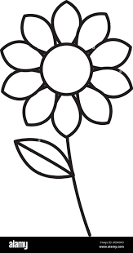**Q.8) Write the name of the followings.**  **4x1=4**

 a) b)

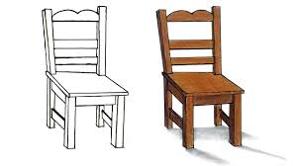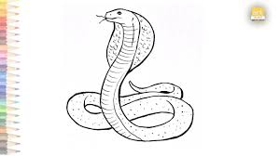 c) d)

Q.9) Answer the following Questions. 6x2=12

1. Name any two body parts of fish .

Ans:-__________________________________________________________.

1. What are living things?

Ans:-__________________________________________________________.

1. What is the name of baby tiger ?

Ans:-__________________________________________________________.

1. Write any two flowers name.

Ans:-__________________________________________________________.

1. What are omnivores animals?

Ans:-__________________________________________________________.

1. Why should we take physical training daily?

Ans:-__________________________________________________________.

1. Name any two vegetables.

Ans:-__________________________________________________________.

**Q.10) Give the definitions of. 2x1.5=3**

a) Tree

_________________________________________________________

__________________________________________________________

__________________________________________________________.

b) Herbs

__________________________________________________________

__________________________________________________________

__________________________________________________________.

**Q.11) Draw the pictures of 3x1=3**

**Apple Fish Flower**

**Third Terminal Examination**

Model Questions - 2081

Class:-1 Time:- 2:00 Hrs F.M=50

Sub:- Science P.M= 20

**Q.1) Fill in the blanks. 4x1=4**

**( Fly, domestic, wings, animals)**

1. We should take care of ..................
2. Wings are used to ........................
3. Cow is a ...........................
4. Birds have feathers and ............................

**Q.2) True or False. 4x1=4**

1. Birds do not have wings.
2. We should not follow traffic rules.
3. We should take care of animals.
4. We get milk from cows and buffaloes.

**Q.3) Match the following. 4x1=4**

1. Birds Water sources
2. Lake Fresh
3. Tree wings
4. Football Round shape

**Q.4) Choose the correct answer. 4x1=4**

1. Cow moves by ............................ (flying/walking)
2. We need air to .......................... (walk /breath)
3. We get milk from ........................... (dog/cow)
4. We tase with our ......................... (nose/tongue)

**Q.5) Circle the odd one. 4x1=4**

1. Parrot Vulture Crow Fox
2. Running Drinking Cooking Washing
3. Tiger Fox Pencil Elephant
4. Apple Orange Rice Mango

**Q.6) Fill in the missing letters. 4x1=4**

**a) B O _ K b) G R _ W c) H _ ND d) P l _ N T**

**Q.7) Identify the following. 4x1=4**

1. I have a wings ___________
2. I am a having a round shape _________
3. We get honey from _________
4. I live in a den _________

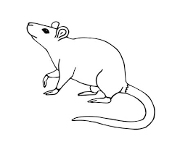**Q.8) Write the name of the followings.**  **4x1=4**

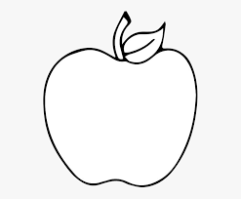 a) b)

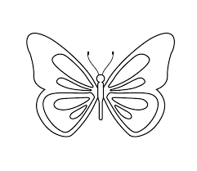 c) d)

**Q.9) Answer the following Questions. 6x2=12**

1. Name any two body parts of cow .

Ans:-__________________________________________________________.

1. Name any four animals having wings?

Ans:-__________________________________________________________.

1. Name any two animals that give us milk?

Ans:-__________________________________________________________.

1. Write any four uses of water.

Ans__________________________________________________________.

1. What are simple game?

Ans:-__________________________________________________________.

1. Name any 2 local games?

Ans:-__________________________________________________________.

1. What is environment ?

Ans:-__________________________________________________________.

**Q.10) Give the definitions of. 2x1.5=3**

a) Non- Living things

_________________________________________________________

__________________________________________________________

__________________________________________________________.

b) Flower

__________________________________________________________

__________________________________________________________

__________________________________________________________.

**Q.11) Draw the pictures of 3x1=3**

**House**

**Annual Examination**

Model Questions - 2081

Class:-1 Time:- 2:00 Hrs F.M=50

Sub:- Science P.M= 20

**Q.1) Fill in the blanks. 4x1=4**

**( dog, mustard, kid, coop)**

1. The baby of a goat is called..................
2. A ........................ guards our home.
3. We get oil from ...........................
4. A hen lives in a ............................

**Q.2) True or False. 4x1=4**

1. Fire is a source of heat.
2. We use umbrellas on a rainy day.
3. A cow has two horns and a tail.
4. We feel cold on a sunny day.

**Q.3) Match the following. 4x1=4**

1. Sunshine teeth
2. Brushing exercise
3. Walking sunny day
4. Stem parts of plants

**Q.4) Choose the correct answer. 4x1=4**

1. A ............................ lays egg. (goat/hen)
2. I brush my .......................regularly. (hair/teeth)
3. Tree are........................... things. (living/Non-living)
4. Mango is a ......................... (flower/fruit)

**Q.5) Circle the odd one. 4x1=4**

1. Lotus Rose Pansy Rice
2. Root Book Leaf Flower
3. Flood Landslide Sunny Windy
4. Car Bus Van Tree

**Q.6) Fill in the missing letters. 4x1=4**

**a) C l _ U _ Y b) F _ S _ c) F _ _ D d) T _ E T _**

**Q.7) Identify the following. 4x1=4**

1. I a wild animal. I live in a ___________
2. I am a baby of elephant _________
3. I am a mammal but I can fly _________
4. I live in a nest _________

**Q.8) Write the name of the followings.**  **4x1=4**

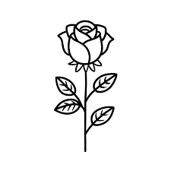 a) b)

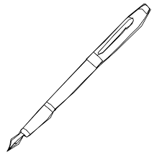 c) d)

**Q.9) Answer the following Questions. 6x2=12**

1. How many horns does a cow have?

Ans:-__________________________________________________________.

1. Write any two ways of caring for plants?

Ans:-__________________________________________________________.

1. What are living things? Any one examples.

Ans:-__________________________________________________________.

1. What is a cloudy day?

Ans__________________________________________________________.

1. What is the name of a baby tiger?

Ans:-__________________________________________________________.

1. Name any 4 animals having only tail?

Ans:-__________________________________________________________.

1. What is physical training ?

Ans:-__________________________________________________________.

**Q.10) Give the definitions of. 2x1.5=3**

a) Tree

_________________________________________________________

__________________________________________________________

__________________________________________________________.

b) Cow

__________________________________________________________

__________________________________________________________

__________________________________________________________.

**Q.11) Draw the pictures of 3x1=3**

**Flower**

Prepared by : Sheetal Dhakal

**Shree Divya Jyoti Basic School**

**Devchuli-12, Gaindi**

**Best of Luck..........**